**Nama : Filusive Nathan Fernanda**

**Nim : 21091397073**

**Output 4.1**

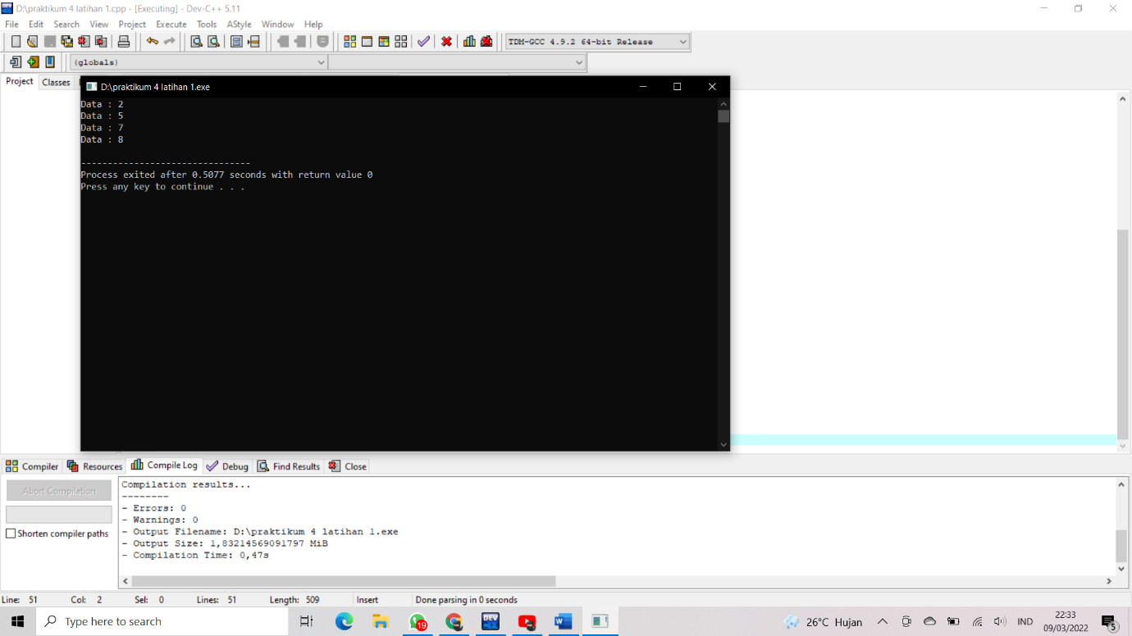

**Output 4.2**

